**Project Design Phase**

**Solution Architecture**

|  |  |
| --- | --- |
| Date | 15 February 2025 |
| Team ID | LTVIP2026TMIDS54366 |
| Project Name | Prosperity Prognosticator: Startup Success Prediction using ML |
| Maximum Marks | 4 Marks |

**Solution Architecture:**

Solution architecture for *Prosperity Prognosticator* bridges the gap between the business problem of startup investment uncertainty and a technology-driven Machine Learning solution.

The architecture ensures structured data processing, predictive analytics, and real-time result generation through a web-based interface**.**

**Solution Architecture :**

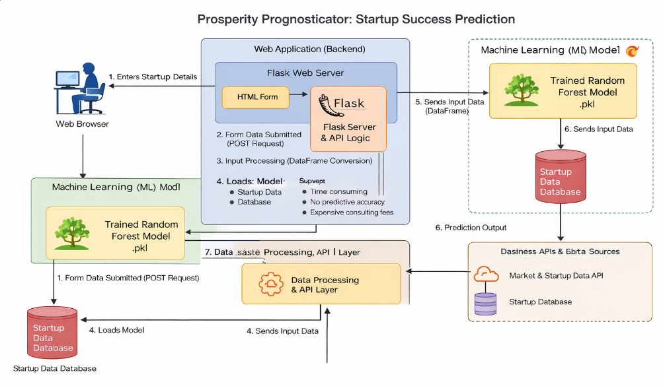

*Figure 1: Architecture and data flow of the 'Prosperity Prognosticator: Startup Success Prediction' application*

**Reference:** [**https://aws.amazon.com/blogs/industries/voice-applications-in-clinical-research-powered-by-ai-on-aws-part-1-architecture-and-design-considerations/**](https://aws.amazon.com/blogs/industries/voice-applications-in-clinical-research-powered-by-ai-on-aws-part-1-architecture-and-design-considerations/)